Recruiting
How to Hire, Attract, Keep and Grow “A Players”

Recruiting is a skill that must be mastered if you are going to create a powerhouse team.

Rather than hire by crisis it is advantageous to set up ongoing recruitment, meaning looking for new and better employees all the time and not just when staffing needs are high.
The advantages of ongoing recruitment are:
- It reduces turnover (i.e. your current staff know you have replacements)
- Increases productivity of existing team (as your team know you have replacements)
- Eliminates hiring by crisis
- Improves company morale and gives you choice and control

Note: Controlled turnover is healthy

There are two main types of recruiting to attract the talent you want:
- Historical/typical: Ads, Seek & other online platforms, Recruitment agencies, newspapers, flyers, associations etc
- Spheres of influence: Your network and quality people who provide quality candidates. E.g. through your personal social media channels, asking quality people, people you know and trust and value can have connections and a network .

The main skills to be a great recruiter are:
- Ability to get and keep rapport
- Interviewing skills
- Listening skills
- Asking questions
- Recognizing and evaluating patterns - understanding human psychology helps

Key Principle
You want to have an ongoing process for candidates (versus a one time event). You want to have at least 3 qualified candidates for available positions. In addition to that, you need to develop an ever expanding group of high quality candidates that are available in a moment's notice to protect the business.

The Process of Creating a Winning Team

Step One: Have an Organisational Chart

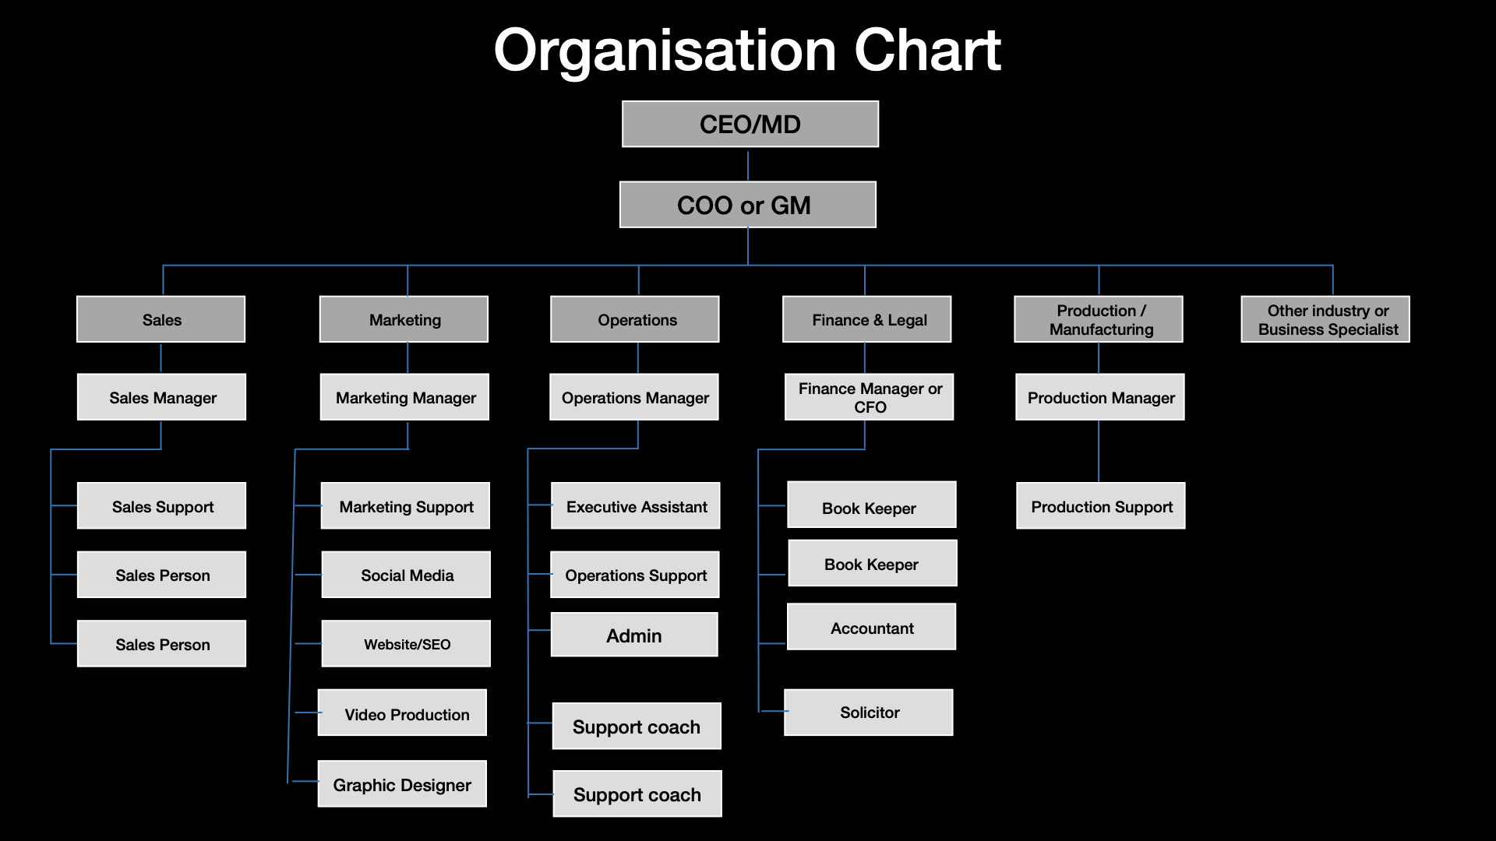

Step Two: Identify your current Organisational Chart then create your 2020 future Organisational Chart (you can colour coordinate current & future roles)

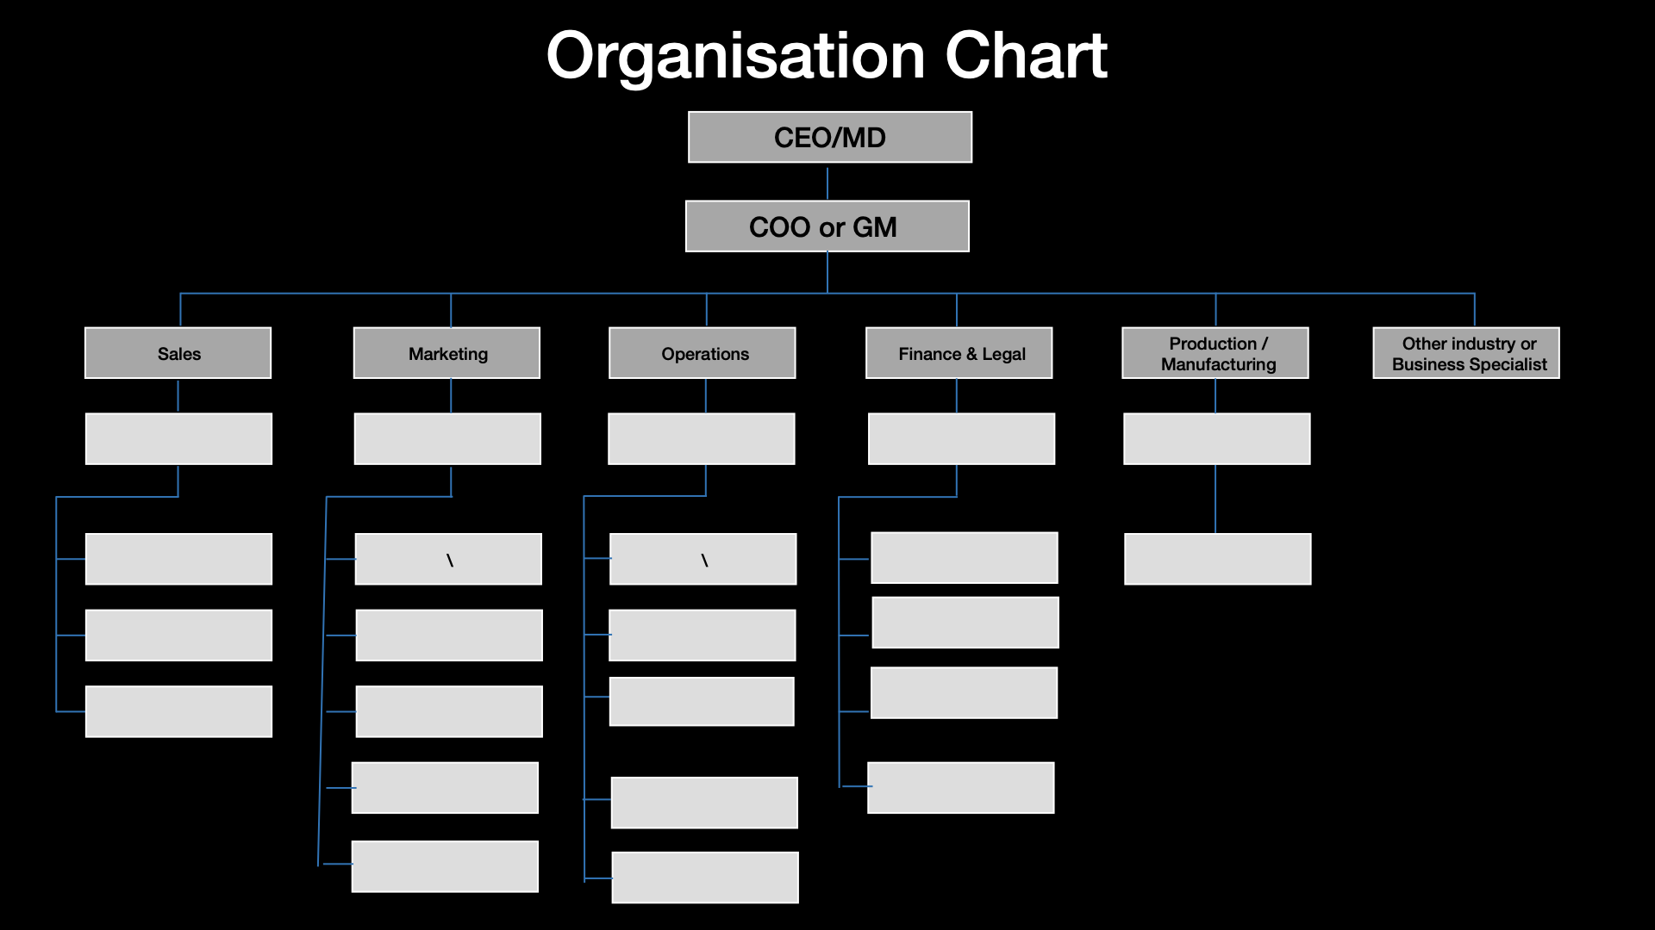

Step Three: Create Job Standard and a Job Description

Job Standard
You must know specifically what you are hiring for:

- This includes the purpose of the job (i.e. the activities, necessary skills and rewards of great performance if any)
- The traits and characteristics of the idea candidate
- The necessary elements for an outstanding team fit (i.e. mission, purpose of company, values of company, attitude, belief systems, pace, etc.)

Job Description

You must be able to tell employees exactly what is expected of them (including all variables of the role) and the standards by which their performance is measured:

- A job description defines the objectives and results expected from the employee.
- Know the award rate of what you can expect to be paying (based on experience and skill level). You can research this online.
- Project into the future what the impact on revenue will be (the cost of hiring vs the expected return on investment. You must set the bar.).

Step Four: Understand and Review the Hiring Triangle
Outstanding companies begin with outstanding people. The results of your organisation cannot exceed the level of performance from each team member.
You want to hire ‘A’ players, talent. Look for the best.

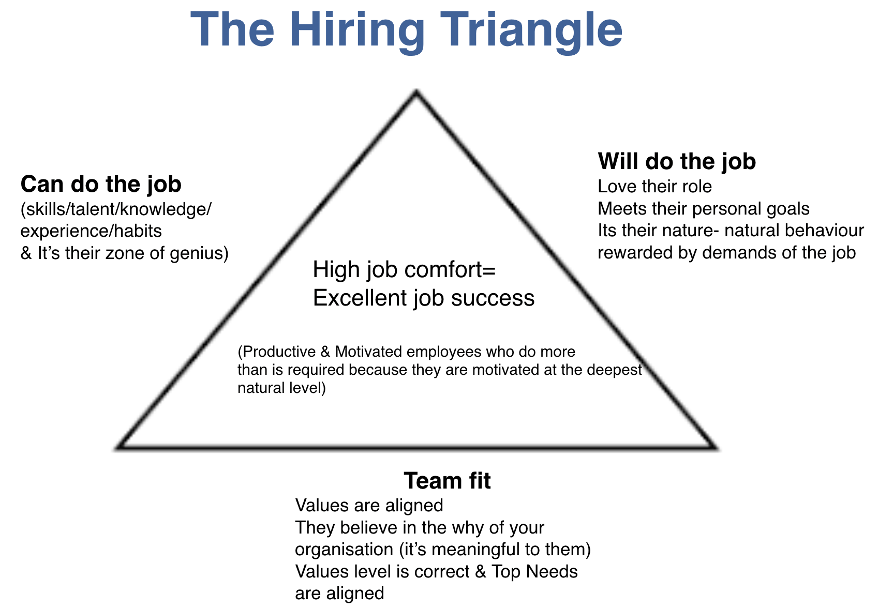

The Hiring Psychology
All people have the potential to be great, given …
- The job rewards their natural behavior (aligns with their true nature)
- Skills and knowledge are sufficient to achieve desired results of the role.
- Management and training is appropriate for the individual for expected results.
- Personal goals can be achieved through excellent job performance - this means knowing how you will measure performance and agree up front on how their goals would be supported. Note: Have a firm understanding on their financial goals if they are there.

Note: When you hire someone who does not have the past experience of having produced results in the area you want, you take a bigger risk and you have to be willing to donate the time and energy at the expense of other things to support them. There is a risk they have more probability of not performing.
The impact on culture after hiring the wrong person has an impact on the business, be aware of the consequences of who you hire. Past experience of producing results is not essential, however it is a great indicator of giving predictable performance.
Step Five: Get Clear on the Specific Job Standards
Instructions for specific questions:
- Make sure to state job objectives and desired outcomes in practical, concrete terms.
- What are the specific work activities that are most frequent and essential for the role?
- State if this person is required or would be/may be required to manage anyone directly.
- Give a complete picture that’s brief about who this person has contact with in the job (internally and externally). State what the purpose is for that, with whom and how often.
- List the required skills, behaviour traits and attitude required.
- List what the prerequisites are for employment - education, prior experience or other.
- Using your best judgement, describe the toughest aspects of the job. These may be the 1-3 things that require the most awareness, effort and persistence to handle.
- Be as specific as possible in giving income range and the formula for pay. (commission rates. Bonus amounts, regular increases etc) Be realistic and specific in describing advancement opportunities.

The Job Standards Form
Job title: ______________________________________
Company name: ________________________________ Date: __________
Type of business: _______________________________
Products and/or services: _________________________
Job description completed by: _____________________ Approved by: _____________

- What are the major objectives or outcomes to be achieved by this person in the job?
- What are the specific work activities that are most frequent and essential in this role?
- Who will be managed and what people will be managed by this person in the job? (if any)
- What or who are the primary contacts in the job? (internally and externally) With whom? How often? What purpose?
- What are the skills, behavior traits and attitude required?
- What are the prerequisites for employment? (education, past experience or other)
- What are the toughest aspects of the job on an ongoing and seasonal basis if any?
- What are the compensations? (income range, pay formula, advancement opportunities, etc)

A job description form must also be filled out. These can be found online.

Step Six: Their Documentation
You need their CV and a cover letter ideally. This must be read and analysed before the interview.

Step Seven: The Interview Questions
In the interview process you want to look that everything on all sides of the triangle is met and that they meet the job standard and will fulfil the job description. You want to find THE best candidate.

You want to have pattern recognition so while you ask the questions look for is this persons:
- Aggressive vs. Supportive
- Sociable vs. Information Preferred
- Responsive vs. Controlled
- Adaptable vs. Conflict Compatible
- Structure vs. Flexible

There is no right or wrong but they have to fulfil what you are looking for.

Meta Programs
Questions to elicit motivational patterns. Metaprograms are a filter in the subconscious mind that allow us to determine the motivational drives of a human being. In combination with eliciting the values of a person this is very powerful.
Meta programs filter the world to help us create our own world. Meta Programs are the most unconscious filters to our perception. They are wholly unconscious but powerful determinants of our personality. They are one of the internal programs or filters that we unconsciously use in determining what to pay attention to. They also provide unconscious drives for a person.
Basic Meta Programs
- External Behavior: Introvert/Extrovert Question: "When it's time to recharge your batteries, do you prefer to be alone or with people?"
  - External Behavior is determined by the basic question of whether a person is an Introvert or an Extrovert. This was described by Jung as an attitude preference. The question answered by this description is, 'What is your attitude toward the external world that is evidenced by your behavior?" An introvert will prefer to be alone; he prefers the internal world of thoughts and ideas over the external world of people and things. Extroverts will want to be with people.
- Internal Processes: Intuitor/Sensor Question: "If you were going to study a certain subject, would you be more interested solely in the facts and their application for the now, or would you be more interested in the ideas and relationships between the facts and their application for the future?"
  - Internal Processes or strategies are directly related to our level of attention and where we focus it. An Intuitor will prefer to perceive the possibilities, the relationships and the meaning of the experiences. A Sensor prefers to perceive the immediate, real, practical facts of experience and life.
- Internal State: Thinker (Dissociated) /Feeler (Associated) Question: "When you make a decision do you rely more on impersonal reason and logic, or more on personal values?"
  - The ability to access a certain Internal State is based on the question of whether a person is associated or dissociated. Thinkers are Dissociated and will make judgments or decisions objectively and impersonally, considering both the causes of events and where decisions may lead. A Feeler will make judgments or decisions subjectively and personally, weighing the value of choices based on their "past" and on how these values matter to others.

- The Adaptive Response: Judger/Perceiver Question: "If we were going to do a project together, would you prefer that it were outlined, planned and orderly or would you prefer that we were able to be more flexible in the project?"
  - The adaptive response determines how people adapt to their environment. A Judger wants to run his own life and prefers to live in a decisive, planned and orderly way. They aim to regulate and control events. A Perceiver wants to let his life happen and will prefer to live life in a spontaneous, flexible way. They aim to understand life and adapt to it.
Complex Meta Programs
- Direction Filter: What do you want in a job/career? What do you want in your life? What's important about what you do?
What is important to you about ______? What do you want to learn (know) in your life?
What will this do for you? What do you want in a _______(name of role) job?
Use to discover Toward/Away From values - whether you have an approach or avoidance type of personality. Toward people are best employed in goal-getting. Away people are excellent at finding errors & work well in Quality Control.
- Reason Filters: Why did you choose your present job? Why are you choosing to do what you do? Are you doing what you want in life? Why are you choosing to learn that [do that behavior]? Why did you decide to go into _______(name of role)?
This tells you if the person is motivated by possibilities in life or by obligations. Possibility people respond to promotional ideas that expand their choices. Obligations people respond to ideas that give them a clear-cut proven path. Often possibilities people can signal they love/enjoy their role. You have to look for this.
- Frame of Reference Filter: How do you know when you've done a good job? Do you just know inside, or does someone have to tell you? How do you know when you've mastered that something? (that you have done a good job in any context)? Do you know inside or does someone have to tell you?
Relates to how people judge the results of their actions - inside or outside - where people find their standards. Internal people will tell you THEY decide - attracted to self-employment. External people need to be managed & supervised - need standard for success to come from outside.
- Convincer Representational Filter: "How do you know when someone else is good at what they do? Do you have to.. ." or 'How do you know that a coworker is good at their job? Do you have to..." (a) See it?, (b) Hear about it?, (c) Do it with them?,or (b) Read about it, or read something they have written?
How do you know when someone else has mastered that role?
Tells which rep. system is used in knowing that someone else does a good job.
- Convincer Demonstration Filter: How often does someone have to demonstrate competency to you before you're convinced? How often does someone have to demonstrate competency [mastery] to you before you're convinced? Do you have to see it? Hear it? Once or more times? Or consistently?
This demonstrates the time sequence for being convinced - how long it takes how many times - what period of time (days, weeks) or every time.
If it is once they are likely to assume they themselves are good at their job until proved otherwise. If it’s a number of times they require a specific number of examples to be convinced. If it's consistent they may never get enough information, may need to be convinced on a daily basis, can be feeling they are always making a decision without enough information. If it's a period of time then they require a specific period of time to be convinced.
- Action Filter: When you come to a situation, do you usually act quickly after sizing it up or do you do a detailed study of all the consequences and then act?
Has to do with predicting how much energy a person will put into pursuing his life's goals - will predict how quickly a person will act.
- Management Direction Filter: Do you know what you need to do to increase your chances for success on a job? Do you know what someone else needs to do? Do you find it easy to tell him?
Allows you to determine or predict the suitability of a person for self-management as well as managing others. Most suited to business applications.
- Affiliation Filter: Tell me about a work situation (or environment) in which you were the happiest - a one-time event. What did you like about it?
Deals with how to assign people to a job or to a group effort:
  - If it's specific they break tasks down into small sequential chunks, they concentrate on the details of work, they are good with details.
  - If it's a general past work experience they can have lots of projects going on at the same time. They can get things out of order, they can sequence things randomly, they are known as big picture people who may be better on overall strategy than executing the details of it.
  - Pay attention to their language. When you ask ‘what did you like about it?’ You want to discover if they prefer working:
    - Independently- which means they enjoy working alone, can take sole responsibility for a job, that they may work best isolated from others. Could be good for a role as a computer programmer or possibly more independent roles. You can sell them on ‘this will leave you alone.’
    - Cooperative as a preferred working style. They want to work with others, enjoy shared responsibility, are a team player with ‘we’ orientation, may not understand hierarchy. You can sell them on team effort.
    - Proximity- they enjoy working with others and having still sole responsibility of the task. They work with people but are in control and you can sell them control and take charge. Then you can have activity-person versus activity-thing.
      - Activity- person - interacts with others, interested in people and their feelings, puts their antenna on other peoples reactions and can be the ‘nurse.’
      - Activity - thing - interacts with others on a personally detached basis, interested in tools, products. Interested in how a system works, overlooks others' feelings. E.g. factory worker.
- The Work Preference Filter: Do you prefer to work with things, systems, or people?
Important in job assignment; indicates a person's preference in working w/things, systems or people.
- Primary Interest Filter: Tell me about your favorite restaurant (work i ng experience, learning experience). Tell me about one of the top 10 experiences in your life.
Does the answer involve People: (who), Place: (where), Things: (what), Activity (how), or Information: (why, what information.)
Important in job assignment. The primary filter pertains to your primary interest in a given event.
- Chunk Size Filter: If we were going to do a project together, would you want to know the big picture first (how it affects the company, nation, etc.), or would you want to get the details of what we're going to do first? Would you really need to know the big picture/details?
Important in communication & in training - relates to how people best receive & incorporate info.
- Relationship Filter: What is the relationship between this year and last year?
One of the systems we use in the process of understanding & deciding:
  - Sameness- Can stay 15 - 25 years in a job.
    - Like the word ‘sameness.’ won’t respond to ‘different.’ Better to use the word ‘improve’ as ads that talk about ‘new’ and different’ turn off these people.
  - Difference- can stay 12-18 months in a job that doesn't evolve or change. Likes the words ‘different and unique change’. Requires variety and change in a job. Intolerant of routine, will force change and poor at long term projects.
- Emotional Stress Response: Tell me about a work situation (one-time event) that gave you trouble. How did you feel about it?
  - Dissociated people may seem cold and unfeeling, but they react to job pressure unemotionally and are good in high-stress situations.
  - An Associate may seem too emotional, but is good in a low-stress personal contact job such as receptionist. Can predict how people will respond in high stress situations. Watch eye accessing cues & listen to predicates.
- Time Storage Filter: I want you to point to the first direction that comes to mind, What direction is the past and what direction is the future for you?
Now point to the direction that is the PAST and the direction that is the FUTURE.
In-time people are not as aware of duration of time as through-time people and may have trouble ending a session:
  - Can be undependable. Through-Time people are aware of duration, think that time equals value. How we store memories - how we access them - how we are oriented to them & how we perceive the continuity of time.
  - “How do you feel when you are 5 minutes late?”
Modal Operator Sequence (MOS) - MOS is what a person says to motivate himself.
What was the last thing you said to yourself just before you got out of bed this morning?
Best discovered by observation over time.
Keep testing until you discover which produces results. [Probationary period] The sequence of Modal Operators (poss. or necessary) that acts as an undeniable motivator to a person.
Identifying values
Tell me the first things that come to mind, what is important to you in life?
What is important to you about your career?

Life values Career values
_____________________ _______________________
_____________________ _______________________
_____________________ _______________________
_____________________ _______________________
_____________________ _______________________
_____________________ _______________________
_____________________ _______________________
_____________________ _______________________
_____________________ _______________________
_____________________ _______________________

6 Human Needs
You want to listen to the top needs that are driving this person as they answer the questions.
You may not ask these questions directly unless really required however you want to discover what are the top 2 needs that are driving them.
Example:
If you have an organisation that is contribution focused where money and status are top values for a candidate, it’s what makes your candidate feel significant.
If you cannot meet their personal goals for money then it could signal an alarm.

The following explains the 6 needs to look out for. You have to discover if your company's purpose or mission would meet their needs or not. At the end of the day you want your company mission and purpose to mean something to each employee.
If they are certainty driven have they avoided change in the past, have they been comfortable doing jobs for longer terms? How have they met their need to feel comfortable and safe?
How have they met their need for variety? Have they frequently changed jobs and roles and have they engaged in side businesses? What meets this need for them? How do they meet their need for significance?
Is it important to them how many likes and followers they have on social media?
Is it important to them they stand in the limelight? How did they meet this need in the past in their work? How do they respond to being challenged in the workplace?
Do they challenge and attack back? How do they meet their need to feel special, important and unique?
How do they meet their need for love and connection? How do they connect with other people?
How do they introduce themselves to you? What is their level of warmth?

Do they allow themselves to receive love and praise?

How do they give love to others? How important is this need to them? How do they meet their need for growth? How do they meet their need for contribution?

Identifying Traits
When it comes to identifying traits the following table tells you what to look for and the method of discovery so you can identify them in the candidate.

Trait | What to Look For | Method of Discovery
Communication Ability | Ability to express self, good listener, impact through words and behaviour | Observation and listening reference check. Why hire you? Ask them to tell you something?
People/Sociability | Shows understanding of people. They have lots of social contacts. Confident with people. Makes friends easily, seeks people, talker, at ease with people, warm/friendly | Non- work activities. likes/dislikes about past jobs, two sided questions, discuss philosophy of working with people, describe people characteristics.
Persistence | Tenacity, singleness of purpose, pursue something over all odds. | Toughest job, examples of tenacity, biggest mistake, past goal achievement.
Hard Working | Professional parents, need to succeed/dollars, strong work habits, like to be doing things. | Typical day, reference check, goals and aspirations, work history/how tough have the last jobs been, evening/weekend activities.
Aggressive | Ego- lies centre of attention, challenge orientated, risk taker, prefers action, seeks responsibility, may need to be restrained, dominating, impulsive, exaggerates accomplishment, involves vs observer, enjoys change, will try to control interview. | Takeaways, weak points, job likes/dislikes, what likes/dislikes about sales, challenge examples, biggest mistake, reference checks, tend towards job responsibility, authority and job that takes initiative
Independance | Dislikes close supervision, preferes to organise on own, likes to make decisions, can endure uncomfortable situations, controls environment | How they like to be managed, examples of past organisational ability, examples of significant decision, reference check, environment of past jobs.
Dependability | Complete what they start, stable home situation, likes stability, prefers predictable situations. | Types of jobs they enjoy, key to success at job, strengths/ weaknesses
Low Aspiration | Second income, not dependant on income | Why do you want this job? importance of wages, what do you expect to earn? goals/aspirations
Service Orientated | Likes things in order, accurate, careful, follows instructions, wants guidance | Ideal job, things that frustrate you, how do you deal with paperwork?

Interview Questions for Screening
Probing Questions
If you ever want to probe the person at any stage of the interview you can ask the following questions:

- What is important about?
- Tell me more.
- Give me an example(s) and experience (s) of that
- In addition to that, what else?
- Take a guess.
  - Warm-up Questions
    - Tell me about your hobbies and work non-work interests
    - What do you do in your spare leisure time
    - What do you know about us and this company? (if they know nothing that shows their level of care in getting this job vs. a 'job.’ is this just another job or did they actually do some homework?) Why are you interested in this job?
    - What professional organisations do you belong to?
    - What do you want in a job?
    - What will having that do for you?

Work History
- What special aspects of your work experience have prepared you for this job?
- Describe for me one or two of the most important accomplishments of your career.
- Tell me about a work project that gave you trouble?
- What kinds of supervision have you received in your previous jobs?
- What kinds of supervision have you used with your subordinates?
- What do you consider your biggest career success?
- Describe for me your biggest disappointments in your career?
- Why would you choose to pursue this kind of career?
- Why are you leaving your present job? Or why did you leave your last job?
  - How long were you in that last job (if you don’t know),
  - How long were you in each of your last 5 previous roles?
(Note: Dig deeply here and ask follow up questions. What is driving THIS person to apply for THIS job?)
- For you, what is important about working?
- Why did you choose your current job?
- Out of all the jobs you’ve had,which did you like the best and why?
- Which job did you like the least and why?
- Where does this job fit into your overall career plan?
- What did you do to improve the company? The job?
- What kinds of co-workers do you like best? Why?

Education and Training
- Tell me about your education.
- What special aspects of your education, private courses or training helped you perform better on the job?
- What courses in school have been most influential in helping you do your job?
- What areas would you most like additional training in if you got this job?
- What were your extracurricular activities?

Career Goals
- What are your future personal and professional goals?
- Where would you like to be in 3-5 years in your career?
- What are your financial goals to be earning 12 months from now?
  - 2 years from now?
  - 3 years from now?
  - 5 years from now?
  - 10 years from now?
Note: Test levels of ambition and willingness to think ahead. What are their goals? I also recommend hiring generally if they see a vision with you for a minimum of 3 years. Can you meet their personal goals? This is extremely important!
- What would you be expecting in remuneration?
- What kind of job do you see yourself holding 5 years from now?

Note: You want someone who can commit long term, I recommend no less than 3 years, 5 years minimum ideally. You don’t want to be the short term bridge for someone at the expense of finding the right person who is aligned to your company mission and purpose.

- What would you most like to accomplish if you got this job?
- What might make you leave this job?
- What would you do if your present employer offered you a raise or promotion?
  - What would you do if you were here for 6 months and another company offered you more money?
  - How would you respond?
- Why did you choose your current job?

Job Patterns
- Everyone has strengths and weaknesses as workers. First can you tell me what your special strong points for this job are?
- What are the things you don’t like to do or work on? What about your previous job frustrated you the most?
Note: This is a less threatening way to ask about weaknesses. Can they be honest and open with where they might need help? Do the job requirements need these traits or skills?

- What are the biggest strengths you will bring to this organisation? What are the 5 things you love to do at work?
Note: you are looking for them to sell their abilities or accomplishments. See if they mention multitasking and working as part of a team.
- Tell me about one of your favourite working experiences.
- What did you like about that?
- How do you know when you have done a good job?
- At your most recent job how did your supervisor evaluate your performance? What were some of the upsides and downsides of the evaluation?
- What are some of the things your current employer could do differently to be more successful?
Note: Sour grapes or constructive criticism? What is their level of thinking … remorseful or empathetic and compassionate. Do they think small or big?
- What do you think are the 5 most important things for you to be successful in this job?
Note: Test focus … individual strengths vs team/greater goals of the company.
- Please walk me through a typical day at your current or previous job and tell me about your boss and your relationship to him/her?
Note: This question tests CV against job title and actual duties. It proves their level of supervision and amount of autonomy. It also shows the level they think on; daily or longer term.

- What is the relationship between what you are doing this year on the job and last year?
- Do you consider yourself a punctual person? Is that important to you? How many times have you been late in your previous or current job if we were to speak to them?
- How do you know when someone else is good at their job?
- Why do you feel you are qualified for this position?
- What's one question you wouldn't want me to ask?

Role Specific Questions:
Sometimes you have to ask questions that are specific to the role they are applying for.
For example, if it’s a sales role you may want to:
- Do a role play
- Ask their beliefs about selling
- Ask how they respond in long periods of no sales, ask how they would respond to other sales people doing well and they weren't, etc etc.

Preframe Personality Testing (optional):
Let them know if you are going to conduct any other personality testing. This is recommended if you can.
You can conduct a DISC assessment (this can be found online), Get them to do the HEXACO test (online) and a Myers- Brigs if you want. The Dark triad test is a good one for manipulative and dishonest personality traits.

Conduct the Personality Testing (optional):
Attain this data online or in person. You can conduct a DISC assessment (this can be found online). Get them to do the HEXACO test (online) and a Myers- Briggs if you want. The Dark triad test is a good one for manipulative and dishonest personality traits.

Reference Checking
Eight Keys to Effective Reference Checking
- Get to the immediate supervisor of the employee.
- Ask for their help.
- Emphasise confidentiality - ask if they need to call you back.
- Verify who you are.
- Layer your questions: probe and soften questions.
- Describe the toughest aspects of the job you have - ask how will the candidate handle it?
- Weak points - where could the candidate take development or growth?
- Assure them you won’t reveal the source.

Get Both Personal and Professional References
Let your candidates know that due to the substantial amount of time and money that you invest in selection, training and the development of people, you require four - six character references.
- Work references - Work references are people who know the candidate personally and are in a job category that is similar, if possible to the type of job for which he/she is applying. These people should have insight into the candidates character and potential within your company. Ask for at least 2 - 3 business character references.
- Past employer references - you want to get feedback using the questions below from at least 2 past employers of the candidate.
- Personal references- these are two of the candidates friends, relatives or other associates who he/she knows personally and who would be willing to act as a personal reference.

When making the calls use the form below to gain rapport, and you will get the information you need!

Reference Check
Candidate: ___________________________________ Date: ___________
Company: ________________________ Person contacted: ________________
Phone: _____________________ Title: ______________________
- Introduction- Name, title, company
- _________________________ is a candidate for a position with our company. I would like to verify some of the information he/she has provided to us.
- Were you his/her supervisor? (yes/no) What was his/her duration of employment from ________ to ________.
- Describe his/her work role and responsibility. The type of work he/she did.
- When they started _________________________________________________
- When they left ___________________________________________________
- __________________ monthly earnings of $______________ when he/she left. Is this correct?
- Did he/she have supervisory responsibility?
- What were his/her key job functions and special skills?
- How did his/her performance compare with others?
- Can describe the amount and type of people contact in the job?
- How well did he/she handle or get along with other people?
- Why did he/she leave?
- Would you rehire him/her? yes/no. If not, why?
- What if anything interfered with his/her work?
- Describe his/her strong points
- What were his/her weak points?
- What advice would you give me considering _____________ for this job?
- Is there anything else that would help me understand him/her better?
- Appreciation - thank you very much for your input. You have been very helpful.

Other Comments:

_____________________________________________________________________________
_____________________________________________________________________________

_____________________________________________________________________________

_____________________________________________________________________________

Comprehensive Interview:

There are several outcomes if the comprehensive interview (this is the second interview)
- Gather more information
- Validate the resource analysis
- Create a series of stresses and evaluate the responses
- Hear more of their story
- Gather information about the candidates' behaviour patterns.

During the interview, it’s important that you go back and forth between creating rapport and creating stress. This will help you evaluate if the candidates stress response is appropriate to the job in question. You can do this by the following techniques: silence, questioning their beliefs, challenging their opinions, asking for opinions on tough subjects, making judgements, repeating the question back in a questioning tone, acting disinterested or allowing for interruptions.

Sequence of Effective Comprehensive Interviews:

Step 1: Preparation - Make sure you have completed the first 10 steps of the recruiting process and have done your homework prior to the interview.

Step 2: Rapport/Set Rules - Describe what you are going to do today (validate info, get out any issues, decide if you want to go to the next step, etc.) Intention: Rapport
Step 3: Resource Analysis Review (30-60 min) - Review the resource analysis with the candidate (e.g. DISC model etc) to validate the behavioural assessment. Make sure to get the candidates reaction to this and discuss any issues it brings up (you may need to reframe if the candidate has a negative response). Intention: Stress

Step 4: Personal History (20 mins) - Hear more of their story so you can continue to validate the behavioural assessment. Intention: Rapport

Step 5: Probing Questions (30 mins- 1 hour) - Get behind their stories. See the questions below for a list of potential questions to ask. Intention: Stress
Step 6: Company/Personal Sell (2 - 3 minutes) - Match what motivates the candidate to the company and the job. Describe the facts/benefits of the job and project (future pace) the candidate into the job. Intention: Rapport

Step 7: Concerns/Commitment - Keep the control. Validate the candidate's commitment with a stronger question (i.e if I were to offer you a job, would you be prepared to … )

Step 8: Schedule next step. Intention: rapport

Probing Questions:
Set 1:
- What are the keys to your prior successes?
- What was your relative standing in earlier jobs?
- On a scale of 0-10, what was your level of caring for the goals of your past job(s)? What was the level between 0-10 you feel you had the companies back?
- If you hear gossiping or negativity that you know is destructive to the culture, how would you respond to that?
- In your last 3 roles, did you ever ask for a pay rise? If so, what were the circumstances? Was it inside or outside of the agreed terms?
- If you were asked to do something outside your job role for the sake of getting the higher result (give examples), regardless of what it is, how would you respond?
  - Note if the person is a team player or not
- How would you respond if we asked you to do something outside of your job role?
- If you were feeling negative about something in the company or about another employee, how would you respond?
- Have you ever challenged management? If so, what happened and why?
- Can you give me an example where you have ever gone the extra mile for a company?
- How important is it to you to be right versus doing what’s right?
- How do you respond if another employee was to ask you about your pay?
- How has your past work qualified you for this job?
- What do you think it would take to be a top performer in this job?
- What would be the most difficult part of this job for you?
- What are some of your weak points? What steps have you taken to improve them?
- What are some of your personal and professional goals?
- How would this job help you reach your goals?
- What are your leadership qualities?
- Describe your most difficult achievement/your greatest determination?
- What will you do if I cannot make the job offer?

Set 2:
- What do you do when you are not working? How do you spend your free time?
- Are you familiar with (your company)?
- What do you want in a job?
- Give examples of things that are important to you?
- What is the best way to approach you?
- How would your best friend describe you?
- Tell me about your future goals.
- How do you know you are on the right path?
- Tell me about a work project that gave you trouble.
- What would a former supervisor say about you?
- How do you like to be managed?
- How do you take feedback?
- Tell me about your management style.
- What areas of additional training do you think would be helpful to you?
- What’s your biggest regret?
- What are you most proud about?

Set 3 - Questions to Probe Further:
- What else can you tell me?
- Help me understand that.
- Can you give me an example of how that works?
- How do you see this working?
- What else do I need to know that hasn’t been asked yet?
- Can you clarify or elaborate?

Set 4 - Family Discussion:
- Find out who the dominant person is in the candidate's life.
- Find out what his/her feelings about the candidate taking this job and what types of influence the family will have on the candidates job performance.
- Discuss the types of things the candidate will be doing that would be useful and/or necessary to know (i.e. travel).
- Sell the company, answer their questions, and ask any questions you might still have.

TIPS:
- Do NOT talk about money.
- Do NOT use the clipboard, journal or take notes.

Decision/Expectations:
Five steps to making your final decision:
- Review all your data.
- List the candidates strengths and evaluate their can do/will do/team fit.
- List their weaknesses and evaluate them.
- Project (document in writing)
- Training needs
- Management time & effort
- Performance level (short & long term)
- Relationship with peers, others
- Other
5. Discuss with any other key managers and make a final decision.

Conduct an Expectations Interview: The 9 Steps to Follow with Candidates:
- Establish (establish) rapport
- Personal sell of yourself and company
- Trial close (explore any concerns)
- Review the job description (this is the first comprehensive review of this)
- Establish expectations/performance standards
- Describe your role as it relates to their management.
- Ask a commitment question: given that we can meet your economic and growth needs, are you prepared to commit to x (this is the first time this is talked about)
- Welcome/money & benefits talk.
- Establish a start up plan and date.

TIPS TO TERMINATING ANY STAGE
OF THE INTERVIEW
You do not know what to stay in the interview any longer than you have to if they are not the right person. Here are some tips to help keep the candidates identity in tact.
- Ask questions of the candidate to jointly determine their traits.
- Sincerely compliment them on their traits to build their identity (may positive traits, good person etc).
- Describe the bad or toughest parts of the job and contrast these with the candidates traits and desires.
- Let them know the job isn’t really right for them - leave their identity in tact.
- Stand up, extend your hand and express your appreciation.
The High Performer Criteria:
- Habits - On a scale of 0-10 does this person have habits that support their success?
- Skills - On a scale of 0-10 do they possess the skills internally and externally to succeed?
- Health - Do they have a healthy balance between family, career, recreation? Do they have the energy to be a high performer? * Answer both these on a scale of 0-10
- Attitude on a scale of 0-10 what is their attitude towards themselves? Co-workers and the company?
- Genius- on a scale of 0-10 does this role align their genius?
- Love and enjoyment- on a scale of 0-10 how much are they going to love and enjoy this role?
- Personal goals - on a scale of 0-10 does this meet their personal goals?
- Knowledge of company/product/market - on a scale of 0-10 do they possess the knowledge required on the company/product and market?
The Gold Medal Team:
- It’s better to have fewer people who are quality and better paid.
- Make sure you measure consistently enough the performance of the person to ensure they are a right fit for the position. Do this early in the game
- Depending on your business - you must have 2 recruitment people (or divisions depending on the size of the organisation) who will continually and actively recruit new quality people - one fully devoted to the sales department and one for the rest of the company.

Criteria & Qualities to Look for in Employees:

- How they deal with stressful situations - when they are under stress do they respond with anger, do they internalise, blame others, not knowing what to do. Do they want to avoid people who create stress or want to avoid people who place responsibility on someone else?
- Team fit (align with values of company, needs and values level).
- Mission orientation.
- Outstanding skill sets.
- Ability to learn quickly and adapt to change.
- Proactive, hungry, driven.
- Responsible.
- Solution orientated.
- Are not drama seekers, have the ability to seek resolution.
- Have the back of the company.
- Possibility orientated/moving towards metaprograms.
- Take full ownership and responsibility.
- Are a team player.
- Are honest, genuine, caring people .

Tiered Talent:
- Gold - High skill sets, drive and mission orientation.
- Silver - High skill sets, high drive and mission orientated an ability to learn. They know where to place responsibility and ownership.
- Bronze - Medium skill sets, medium drive, mission orientated. Coachable to at least silver within 90 days.

General Rule:
As a general rule, what a salesperson nets for the company should be approximately and at least 10 times his/her salary.

